Media Based Learning Object
Tisa Fischer
Prof. David Taylor
EDT 607
September 10, 2016

Title
The title of this web page is “Getting to Know Google Slides.” The subtitle is “Technology Skills for the 21st Century.”
Description
This web page is designed for 4th-8th grade students who are learning to use Google Slides as part of their class presentations. This will be a step-by-step guide for students to follow as they learn how to create slides in Google Slides.
Objectives
- At the end of this tutorial, students will be able to create a presentation in Google Slides
- When given an example of a slide, the student will identify all 5 elements of slide design with 80 percent accuracy.
- When given a specific topic, the student will create a presentation using all 5 elements of slide design with 80 percent accuracy.
Steps
Prior to starting the learning module, students will need to have set up their Google accounts and know their passwords.
Step 1: Sign in to your Google account --> go to google.com
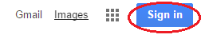
Step 2: Click the waffle in the upper right hand corner to open up Google apps.
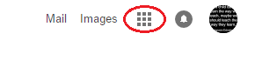

Step 3: Select Slides

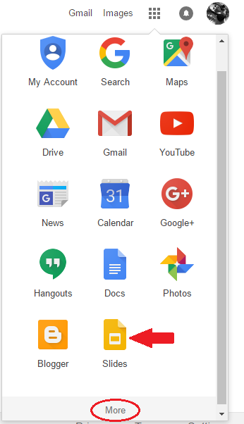

If you don't see the app for Google Slides you will need to click More Tools.

Step 4: In the Slides menu select new presentation--> Blank

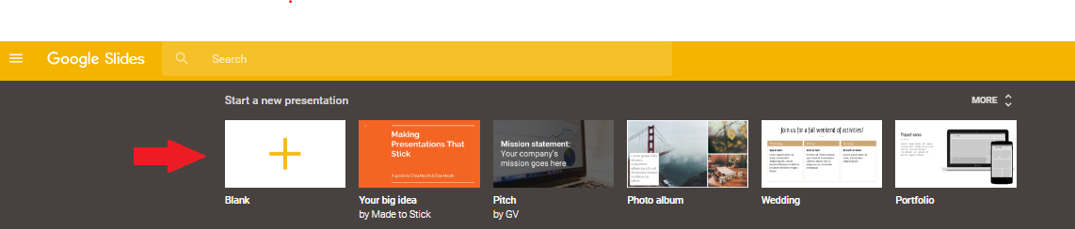
A new presentation will open up in Slides.

Step 5: Give your presentation a Title

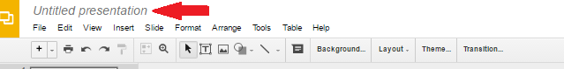
This helps to locate the presentation later more quickly.

Step 6: The first Slide is your title page

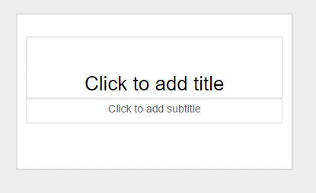
Your title should be centered and larger than the subtitle.
Your subtitle should include your name and any identifying
information, like your e-mail address.

Step 7: Click Slide at the top of the page to insert a new slide.

Continue adding as many slides as needed to complete your presentation.

This is the layout for “Getting to Know Google Slides”.
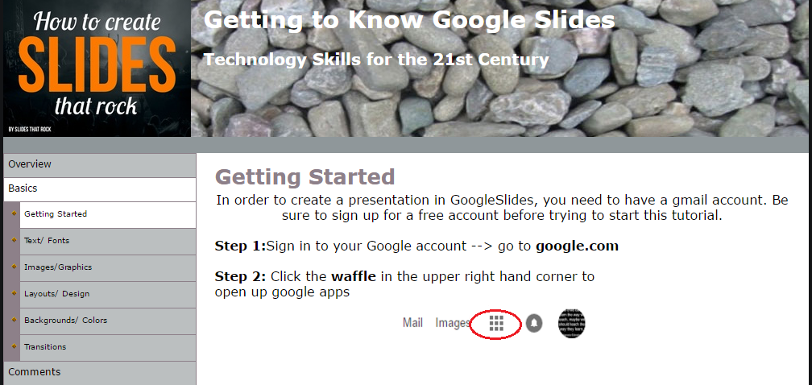

References
Lee, W., & Owens, D. (2006). Multimedia-Based Instructional Design. (2nd ed.). San Francisco, CA: Pfeiffer.
Piskurich, G. (2006). Rapid Instructional Design: Learning ID Fast and Right. (2nd ed.). San Francisco: Pfeiffer.

