Learning Object Project: Storyboard Content
Josue Duarte
May 11, 2016
National University
EDT 607
David Taylor

Title
The main title of the learning object, webpage, will be “Storybird: Write a Problem” Below the afore mentioned title will be a subtitle that reads, “Creating Math Stories”

Description
This learning object will take 3rd to 8th grade students through a step-by-step guide on how to utilize Storybird in order to develop an interactive and engaging math problem narrative. The student will create their own Storybird account that can be reused after the completing of the course. Students will also learn how to use the available art to build a story. Upon the creating of a story, students will learn how to share it with others.
Objective
By the end of the training, trainees will be able to:
- Log-in and create at least one narrative using the web 2.0 tool, Storybird.com
- Using grade level math standards, students will develop a math problem using a narrative created in Storybird.com

Steps
Prior to the training session, trainees will need to have gone to Storybird.com and created a student account. Additionally, students will need to have their district approved grade level math curriculum. Students will then log into their accounts and proceed forward to begin the tutorial by following these steps:
- Step One: Getting Started
- Click on “CREATE” at the top of the screen
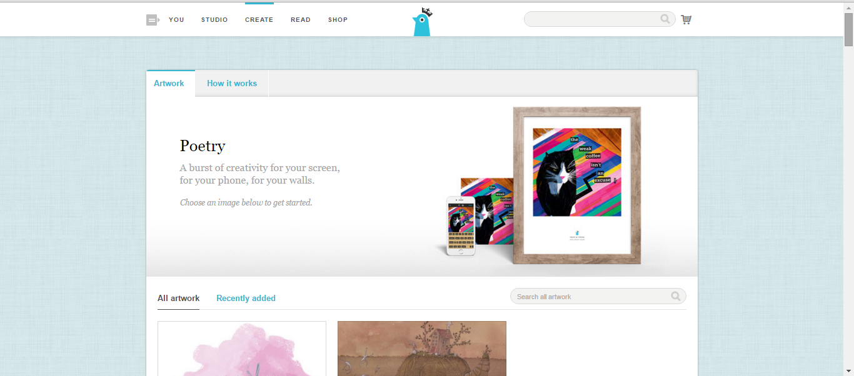
- Select an image you want to use for a story.
- After choosing artwork, click on it and choose “Use this Art” and then “Picture Book.”
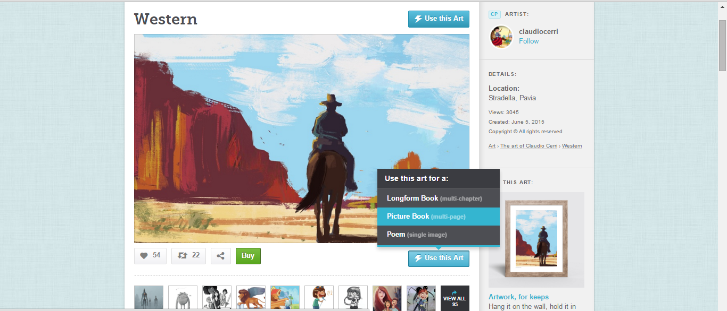
- Step Two: Working with the gallery
- Choose a picture from the side panels and drag it to the story board.
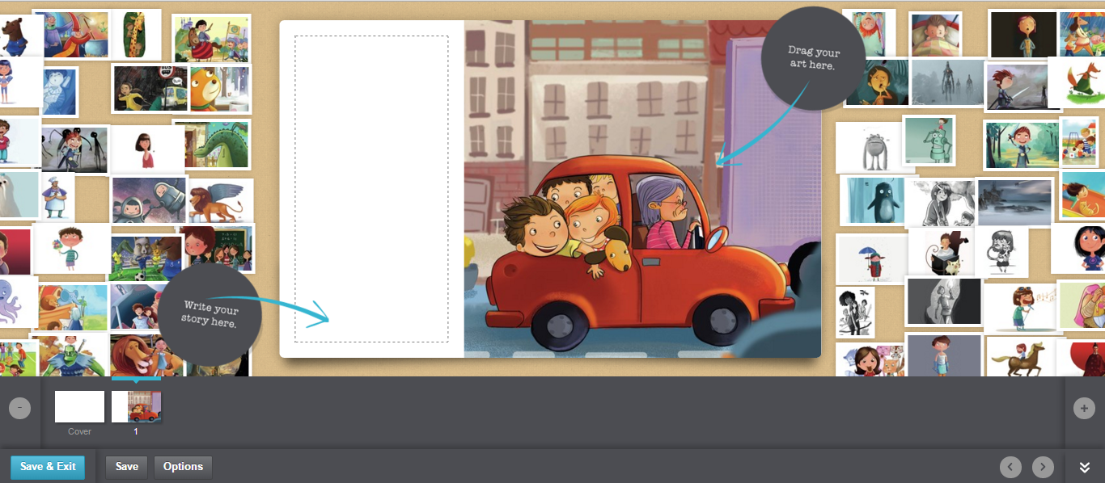
A
B
- Type your math problem directly on the storyboard screen. (A)
- Each time you want to add a picture, click add page symbol "+" (B)
- Step Three: Add a title page
- Click on the “Cover” square at the bottom of the page in the story board.
- Add a title, name, and cover art.
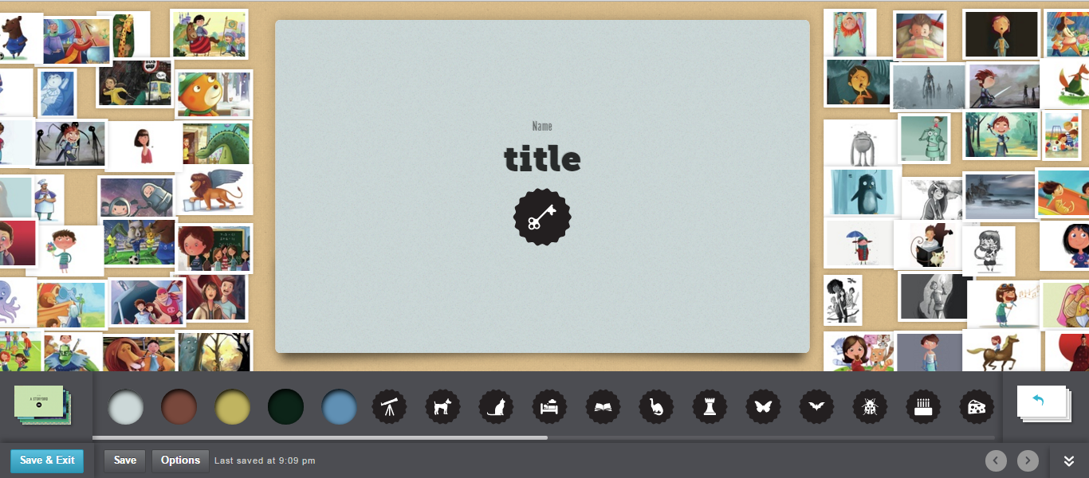

- Step Four: Saving and Publishing your story
- Save your story any time by using the “Save” button on the bottom right.
- When your story is complete, publish the story so others may view it. Click on “Save and Exit” and select the desired settings.
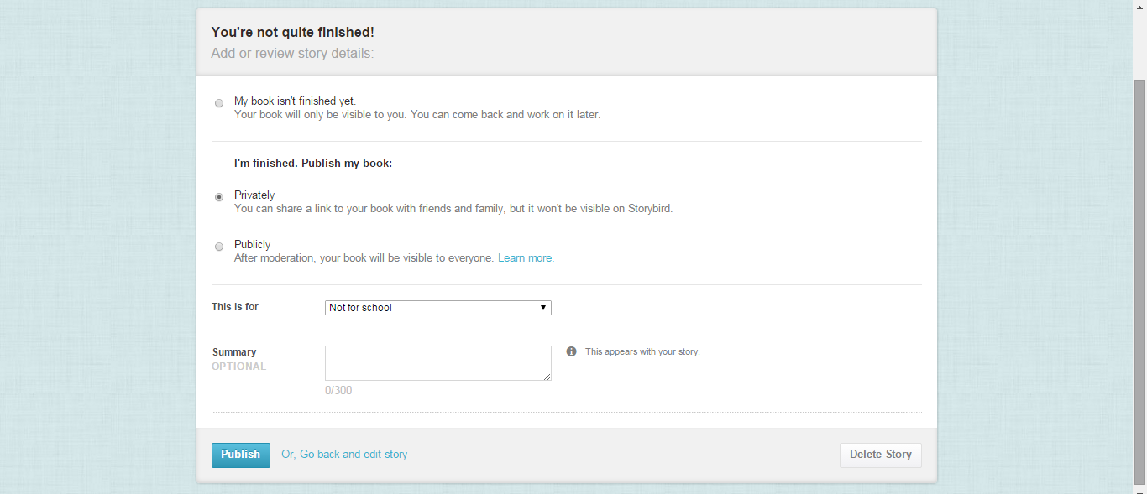
- Click on “Publish”
- Step Five: Sharing your Storybird
- To share your story, click on the “Share” icon and select the method in which to send your story.
- 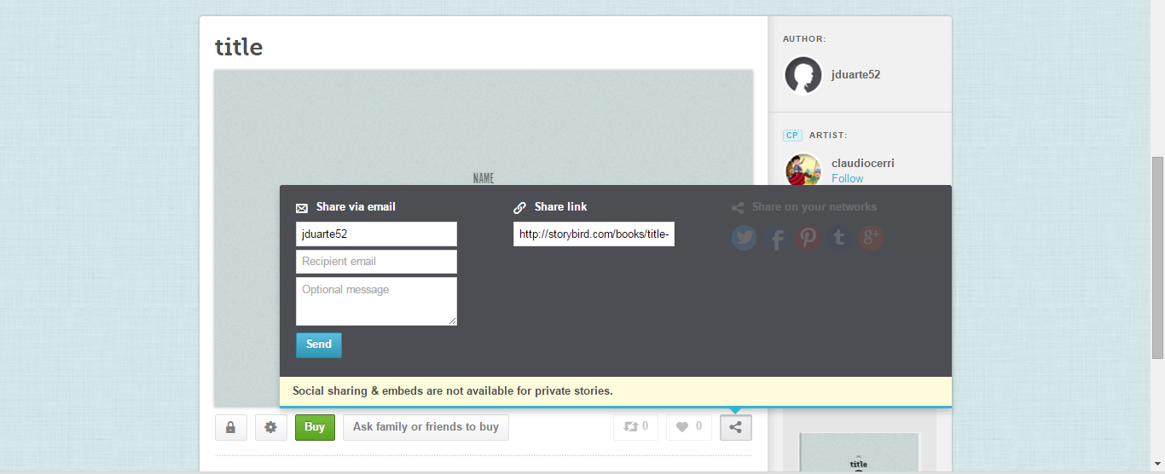
- You may e-mail, share by copying the link, or use a social media link.

- Step Ten: conclusion
- You have finished the tutorial please log out

Basic Layout of Page
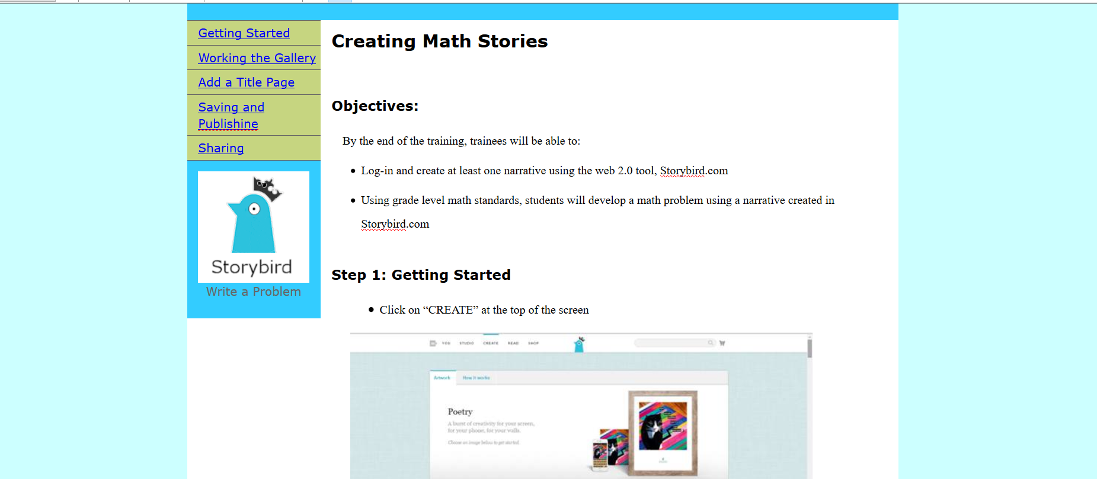

References
Lee, W., & Owens, D. (2006). Multimedia-Based Instructional Design. (2nd ed.). San Francisco, CA: Pfeiffer.
McGreal, R. (2004). Learning Objects: A Practical Definition. Retrieved from http://www.itdl.org/journal/sep_04/article02.htm
Piskurich, G. (2006). Rapid Instructional Design: Learning ID Fast and Right. (2nd ed.). San Francisco: Pfeiffer.

