Learning Object Project: Multimeter Storyboard Content
Julio Lugo
September 10, 2016
National University
EDT 607
Professor David Taylor

Learning Object Content
Title
The main title of the learning object web page I am creating is "Basic Diagnostic Skills for the Electronic Technician: How to use a Multimeter." One of the lessons that form the basis of this course will be "How to measure the resistance of a light bulb."

Description
The learning object will teach apprentice level technicians the basic operation of a multimeter. The students will also learn how to use a multimeter to measure resistance, current, and voltage. The ability to use a multimeter is a technician's most basic skill. All technicians need to know how to use test equipment.

Objective
Upon completion of the training the student/technician will be able to:
- use a multimeter to measure resistance.
- use a multimeter to measure voltage.
- use a multimeter to measure current.

Steps
Prior to the training session, each student will need to have access to a standard multimeter. A multimeter will be provided for the students use while in the classroom. It is highly encouraged that each student reviews the YouTube video, "Reading an Analog Meter," to refresh the information that was taught in the first lesson.
- Step 1: Conduct multimeter set-up.
- Turn Multimeter on to measure Ohms/resistance (Ω)
(insert picture of turning dial to the resistance position)
- Install/insert negative (black) test lead into jack labeled (- or COM)
(insert picture of the negative (black) lead)
- Install/insert positive (red) test lead into jack labeled (+)
(insert picture of positive (red) lead)
- Step 2: Measure the resistance of a light bulb. The student must locate the two electrical points of the light bulb (instructor may assist if needed). The two electrical points are the threads and the center of the bottom of the base.
a. press the black probe against the threaded base
b. press the red probe against the center tab on the bottom of the bulb (if needed, a fellow student can assist by holding the light bulb. If assistance is used, ensure the helper only touches the glass portion of the light bulb.
(insert picture of leads and light bulb)
c. observe the multimeter needle move from resting at the left and move quickly to 0 on the right.
(insert picture of multimeter with needle measuring 0)

Basic Layout of Page
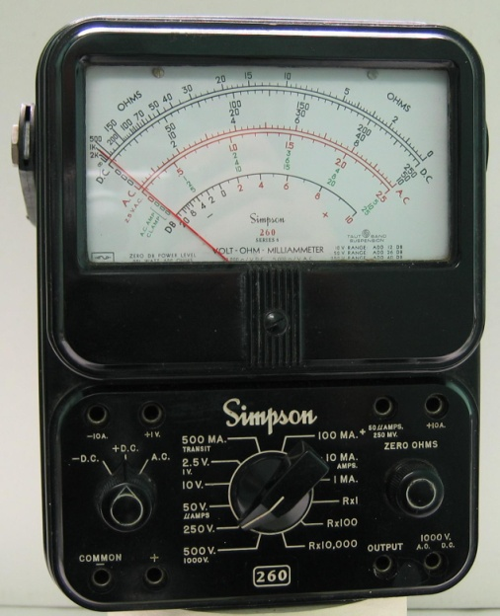

Insert YouTube Video: Reading an Analog Meter.
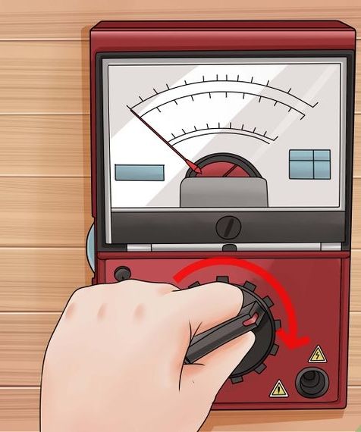
Step 1: Conduct multimeter set-up.
- Turn Multimeter on to measure Ohms/resistance (Ω)
- Install/insert negative (black) test lead in to jack labeled (- or COM)
- Install/insert positive (red) test lead in to jack labeled (+)
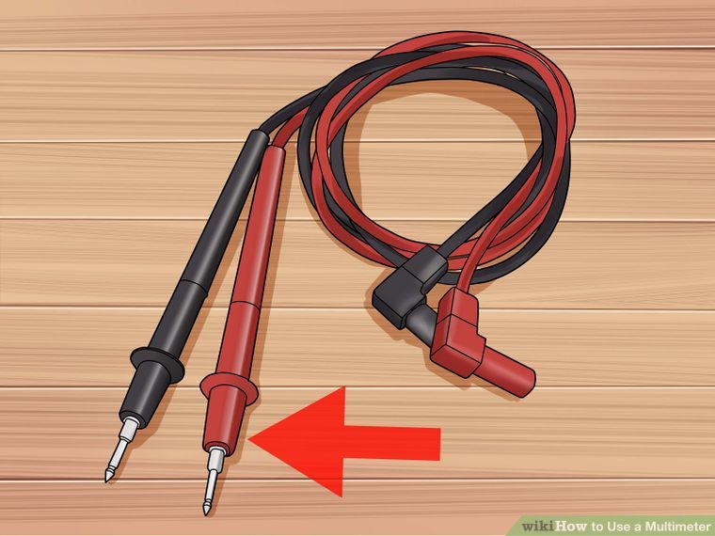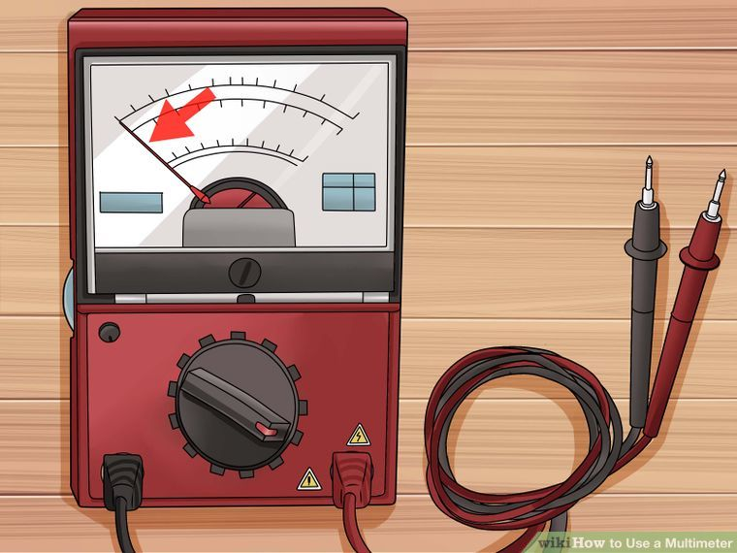
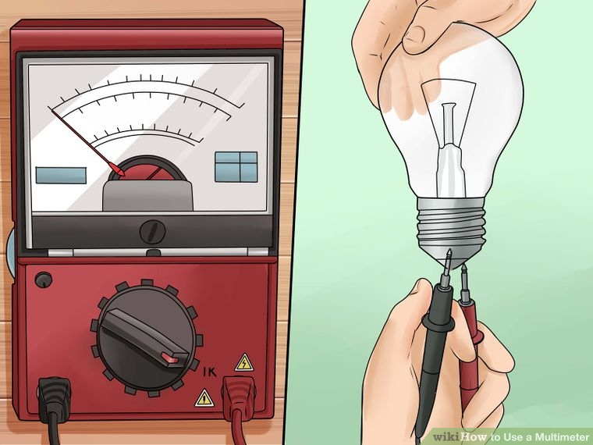
Step 2: Measure the resistance of a light bulb.
a. press the black probe against the threaded base
b. press the red probe against the center tab on the bottom of the light bulb
c. observe the multimeter needle move from resting at the left and move quickly to 0 on the right.
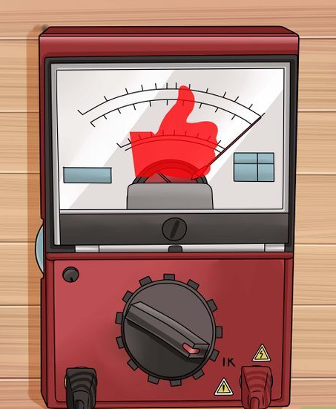

Example of a satisfactory meter reading for an operational light bulb.
References
Lee, W. W., & Owens, D. L. (2004). Multimedia-based instructional design: Computer-based training, Web-based training, distance broadcast training. San Francisco: Jossey-Bass/Pfeiffer.
Wikihow (2016). How to use a multimeter. Retrieved on September 9, 2016, from http://m.wikihow.com/Use-a-Multimeter
Academic Technology Lattc. (2013, October, 23). Reading an Analog Meter [Video file]. Retrieved on September 11, 2016, from https://www.youtube.com/watch?v=9rGDx92McTY

