Learning Object Project: Content and Layout

Margaret Tkach

National University
EDT 607: Media Based Learning Objects
Instructor: David Taylor
December 8, 2013

Title:
Working with Tables
Description:
This learning object will take student through the steps needed to insert a table in a MS Word document, format the table and add style and design changes. Step by step directions and screen captures will be provided to support learning. This learning object would be incorporated into a larger site that covers a wide range of MS Word skills.
Objectives:
- Given data to include in a word processing document, students will insert a blank table, apply format changes and design features.
- Given specific data, students will create a word processing document that includes a table containing merged cells with border and shading styles to enhance the look of the content.
Steps:
INSERT
To insert the table:
- Select the Insert tab.
- Click the Table button.
- Move your mouse over the desired number of columns and rows.
- Click on the select cell.
Your table is inserted into your Word document with evenly spaces columns and rows.
To insert a large table:
- Select the Insert tab.
- Click on the Table button drop-down menu.
- Select Insert Table.
- Select the number of columns to insert in the Columns field.
- Select the number of rows to insert in the Rows field.
- Click Ok.
MOVE
To move the table:
- Bring your mouse pointer over the table. Look for the small Cross Icon at the top-left corner of the table as shown below.
- Click over the small Cross Icon which will select the whole table., use
- Click the Cut button or simply press Ctrl + X keys to cut the table from its original location.
- Place your insertion pointer at the location where you want to move the table
- Use Paste button or simply press Ctrl + C keys to paste the table
RESIZE
Follow these simple steps to resize a table in a word document.
- Bring your mouse pointer over the table - a small Resize Icon will appear at the bottom-right corner of the table.
- Click the Resize Icon until it changes to diagonal double sided arrow
- Click and drag the table
  - Up to make it shorter
  - Down to make it larger.
  - Diagonally to change both the width and height together
MERGE CELLS
You can combine two or more cells in a table by simply erasing the line that separates them.
To Merge Cells:
- Click the Eraser command button found in the Draw Borders group
- The mouse pointer changes - Click a line and it's gone.
- Click the Eraser button again to stop merging.
To Merge Cells (alternate method):
- Select the cells to be merged by highlighting
- Right click the mouse
- Select Merge Cells
INSERT/DELETE ROWS AND COLUMNS
It’s easy to expand your table by adding rows and columns
To Add a Row Above or Below an Existing Row:
- Place the insertion pointer in a row where you wish to add the new row.
- Right click the mouse.
- Select Insert then Insert Rows Above or Below.
- A new row appears above or below the insertion pointer.
- Shortcut for adding rows: place the insertion pointer in the bottom right cell of the table and hit Tab
To Add a Column:
- Place the insertion pointer in a column adjacent to the location you wish the new column to appear.
- Right click the mouse. A menu will appear.
- Select Insert then Insert Columns to the Left or Insert Columns to the Right.
To Delete a Row or Column:
- Select the row or column.
- Right click your mouse. A menu will appear.
- Select Delete Cells.
BORDERS AND SHADING
Change the look of your table by adding Borders and Shading:
To add Borders:
- Select the cells you wish to add a border to.
- From the Design tab, select the desired Line Style, Line Weight, and Pen Color.
- Click the Borders drop-down arrow.
- From the drop-down menu, select the desired border type.
- The border will be added to the selected cells
To add Shading:
- Select a row or column where you want to apply shading.
- Click the Border Button to open the dialog box.
- Click Shading tab
- Select fill, color and style and whether this border should be applied to cell or table.
PRACTICE TIME
Provide a link to practice assignments.
ADDITIONAL RESOURCES
Provide a link to practice assignments.
Working With Tables
Getting Started | A table is a grid of cells arranged in rows and columns. Tables are used to present information in an organized manner and can be customized to meet your needs.  In this lesson, you will learn how to, apply table styles, format tables, and create blank tables.  INSERT  To insert the table:  - Select the Insert tab.  - Click the Table button.  - Move your mouse over the desired number of columns and rows.  - Click on the select cell.  Your table is inserted into your Word document with evenly spaces columns and rows.  Screen Capture  To insert a large table:  - Select the Insert tab.  - Click on the Table button drop-down menu.  - Select Insert Table.  - Select the number of columns to insert in the Columns field.  - Select the number of rows to insert in the Rows field.  - Click Ok.  Screen Capture  “Back to Top” Link  MOVE  To move the table:  - Bring your mouse pointer over the table. Look for the small Cross Icon at the top-left corner of the table as shown below.  - Click over the small Cross Icon which will select the whole table., use  - Click the Cut button or simply press Ctrl + X keys to cut the table from its original location.  - Place your insertion pointer at the location where you want to move the table  - Use Paste button or simply press Ctrl + C keys to paste the table  Screen Capture  “Back to Top” Link  RESIZE  Follow these simple steps to resize a table in a word document.  - Bring your mouse pointer over the table - a small Resize Icon will appear at the bottom-right corner of the table.  - Click the Resize Icon until it changes to diagonal double sided arrow  - Click and drag the table  - Up to make it shorter  - Down to make it larger.  - Diagonally to change both the width and height together  Screen Capture  “Back to Top” Link  MERGE CELLS  You can combine two or more cells in a table by simply erasing the line that separates them.  To Merge Cells:  - Click the Eraser command button found in the Draw Borders group  - The mouse pointer changes - Click a line and it's gone.  - Click the Eraser button again to stop merging.  To Merge Cells (alternate method):  - Select the cells to be merged by highlighting  - Right click the mouse  - Select Merge Cells  Screen Capture  “Back to Top” Link  INSERT/DELETE ROWS AND COLUMNS  It’s easy to expand your table by adding rows and columns  To Add a Row Above or Below an Existing Row:  - Place the insertion pointer in a row where you wish to add the new row.  - Right click the mouse.  - Select Insert then Insert Rows Above or Below.  - A new row appears above or below the insertion pointer.  - Shortcut for adding rows: place the insertion pointer in the bottom right cell of the table and hit Tab  To Add a Column:  - Place the insertion pointer in a column adjacent to the location you wish the new column to appear.  - Right click the mouse. A menu will appear.  - Select Insert then Insert Columns to the Left or Insert Columns to the Right.  To Delete a Row or Column:  - Select the row or column.  - Right click your mouse. A menu will appear.  - Select Delete Cells.  Screen Capture  “Back to Top” Link  BORDERS AND SHADING  Change the look of your table by adding Borders and Shading:  To add Borders:  - Select the cells you wish to add a border to.  - From the Design tab, select the desired Line Style, Line Weight, and Pen Color.  - Click the Borders drop-down arrow.  - From the drop-down menu, select the desired border type.  - The border will be added to the selected cells  To add Shading:  - Select a row or column where you want to apply shading.  - Click the Border Button to open the dialog box.  - Click Shading tab  - Select fill, color and style and whether this border should be applied to cell or table.  PRACTICE TIME  Assignment link here  “Back to Top” Link  ADDITIONAL RESOURCES  Links to additional online tutorials or resources  “Back to Top” Link
Insert
Move
Resize
Merge Cells
Insert Row/Column
Borers and Shading
Practice Time

Footer

Graphics:

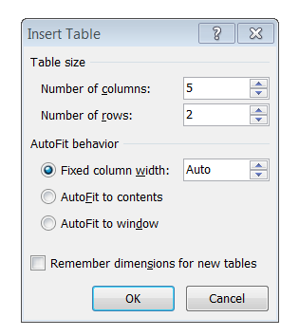
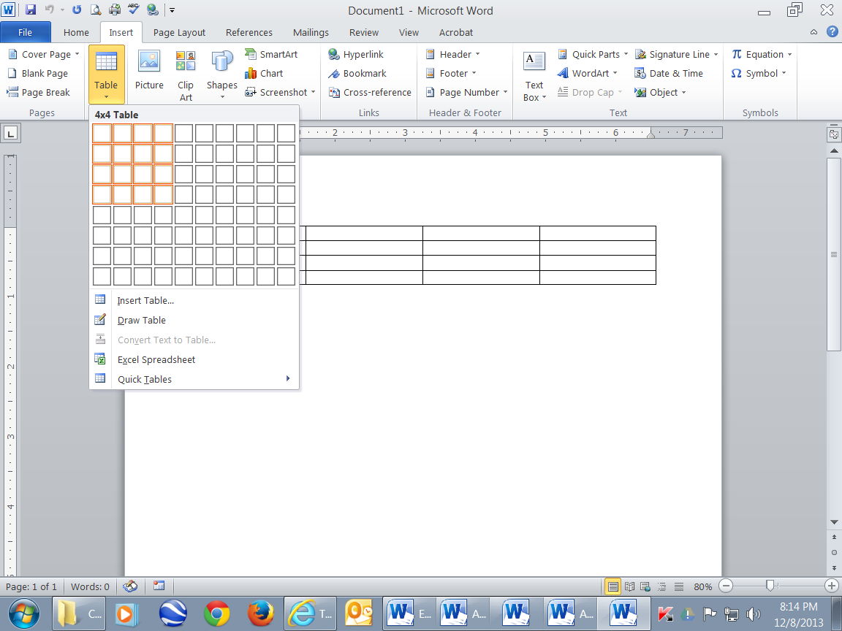
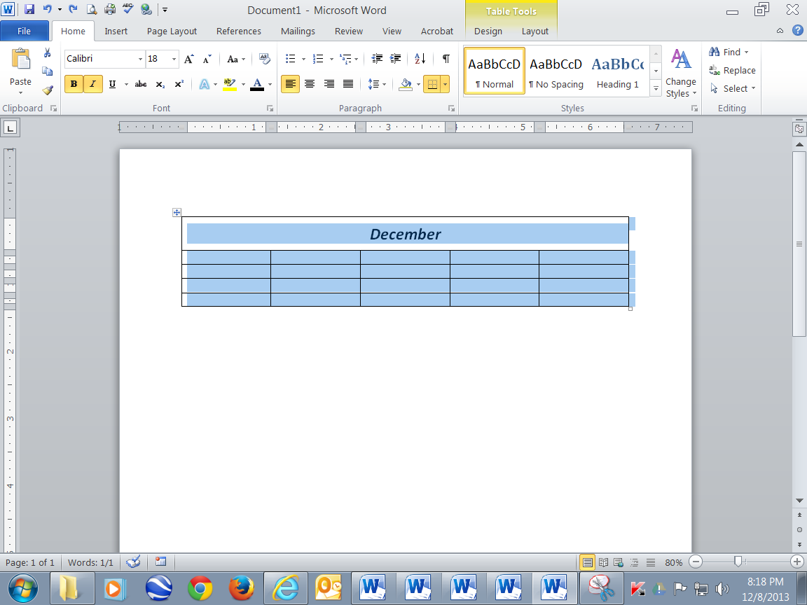
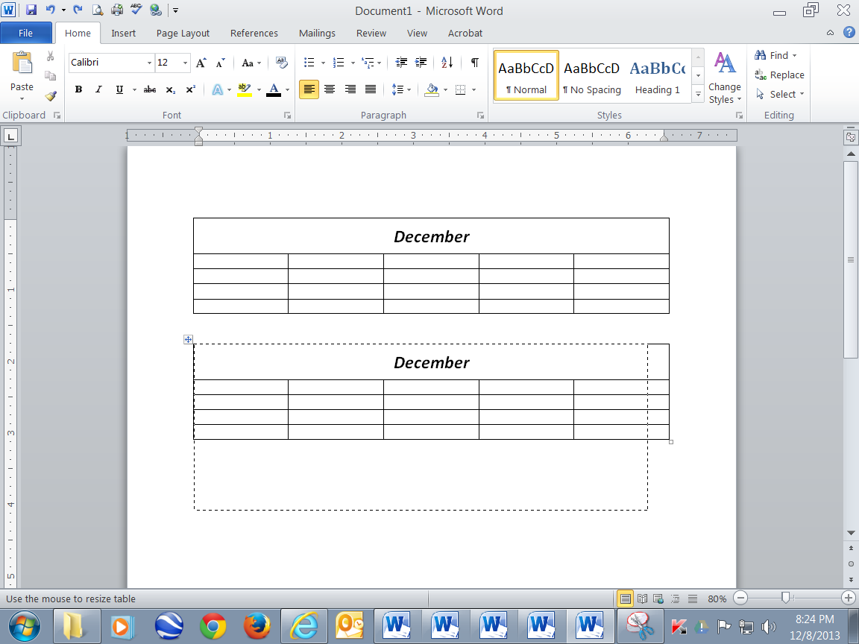
Listed below are screen captures to be used throughout the step-by-step procedures.
